BET HMI Architecture and How-to
There are two HMI displays mounted on M2 truck: Driver display sits behind the steering wheel and the Status display is on the right of the driver. Both the displays are based on the TouchGFX toolchain. The required installation files can be found on the Engineering Team Sharepoint. The implementation for both the displays can found on Git.
Important files:
- en.x-cube-touchgfx-4.26.0: is the TouchGFX installer. This installs the TouchGFX Designer and code generator for generating the C++ backend.
- st-stm32cubeide_2.0.0_26820_20251114_1348_x86_64.exe.zip: The STM32 CubeIDE. The IDE itself is not really required but this installs the required compiler to compile the software. This installs the CubeMX software which is important to configure the STM32H7 RTOS.
- SetupSTM32CubeProgrammer_win64.zip: Optional but is useful if one wants to only flash the executable.
The rest of the document details the HMI software architecture and how one can develop the HMI further. The aim of this document is to allow the future developer to understand the design decisions and also help them to implement new features.

General architecture of TouchGFX based software

The Model-Presenter-View architecture is a widely-used architecture in many applications and specifically well-suited for HMI applications. The three layers embody the “separation of concerns” approach to develop the HMI software, where each part is completely independent of the other.
The Model, represents the HMI backend that communicates with the outside world. In other words, the Model is the interface between the underlying RTOS and the user application. A good example is displaying sensor data. The user-side application doesn’t care where or how the data is being received. It could be over CAN or FlexRay or 5G. The user-side application receives processed data and only takes care of updating specific elements and user interaction. It is the job of the Model to get the data from the underlying RTOS functions exposed to the Model, process it, and forward the data to the View to display.
The Presenter is the interface between the Model and the View. In CAN communication, it is usually the case that a CAN ID comprises of many data fields. However, on the user-side display, one may display this data at different coordinates. The Presenter gathers the data from the Model and forwards the data to specific View functions that display the data at required positions on the display.
The View is what we implement in the TouchGFX Designer. All the widgets, text areas, gauges, images, etc., are defined in TouchGFX and the View is responsible to update the elements. The TouchGFX APIs provide a lot of functions to update and play around with the elements.
The same process follows, only in the reverse order, if the HMI wants to send out some data. For instance, the user may set the target coolant temperature. This target coolant temperature is set using some widget on the view (maybe a slider). The View invokes the Presenter upon update which in turn invokes the Model. The Model forwards this data to the RTOS which then takes care of the communication.
This separation of concerns makes the development cycle a bit lengthy but effective. For a single developer team, the developer has to write the RTOS level communication threads, the data structures, packing/unpacking logic, the complete Model, Presenter, and the View logics. To make the work less assiduous, we developed a simple flow that can be replicated quite easily. Although this flow idea is not new but it has never been used in the context of HMI development.
As a general info, the MVP architecture is quite similar as the MVC architecture. The MVC architecture is what most modern websites, apps, and software is based on. The difference is the C vs P (Controller vs Presenter). In MVC, the Controller handles the user inputs, updates the model, and selects the view. The Presenter, on the other hand, retrieves the data from the Model and updates the View. The Model handles the interaction with the environment. In MVC, that is the job of the Controller.
MVP architecture makes the implementation more modular and maintainable. As we will see later, the whole implementation follows a very specific pattern. And once the pattern is clear, one does not need to know sophisticated C++ to update the code base.
Of course, for major changes such as on the RTOS levels, one needs the expertise but for most cases, it wouldn’t be required.

The Control Flow

Here, we take a deep dive into the configuration of the RTOS and how the FDCAN driver sends and receives the message. In the above diagram, the transmission of messages happens in the reverse order. But before all that, the RTOS must be configured with the relevant data structures and functions.
Configuring FreeRTOS with CubeMX
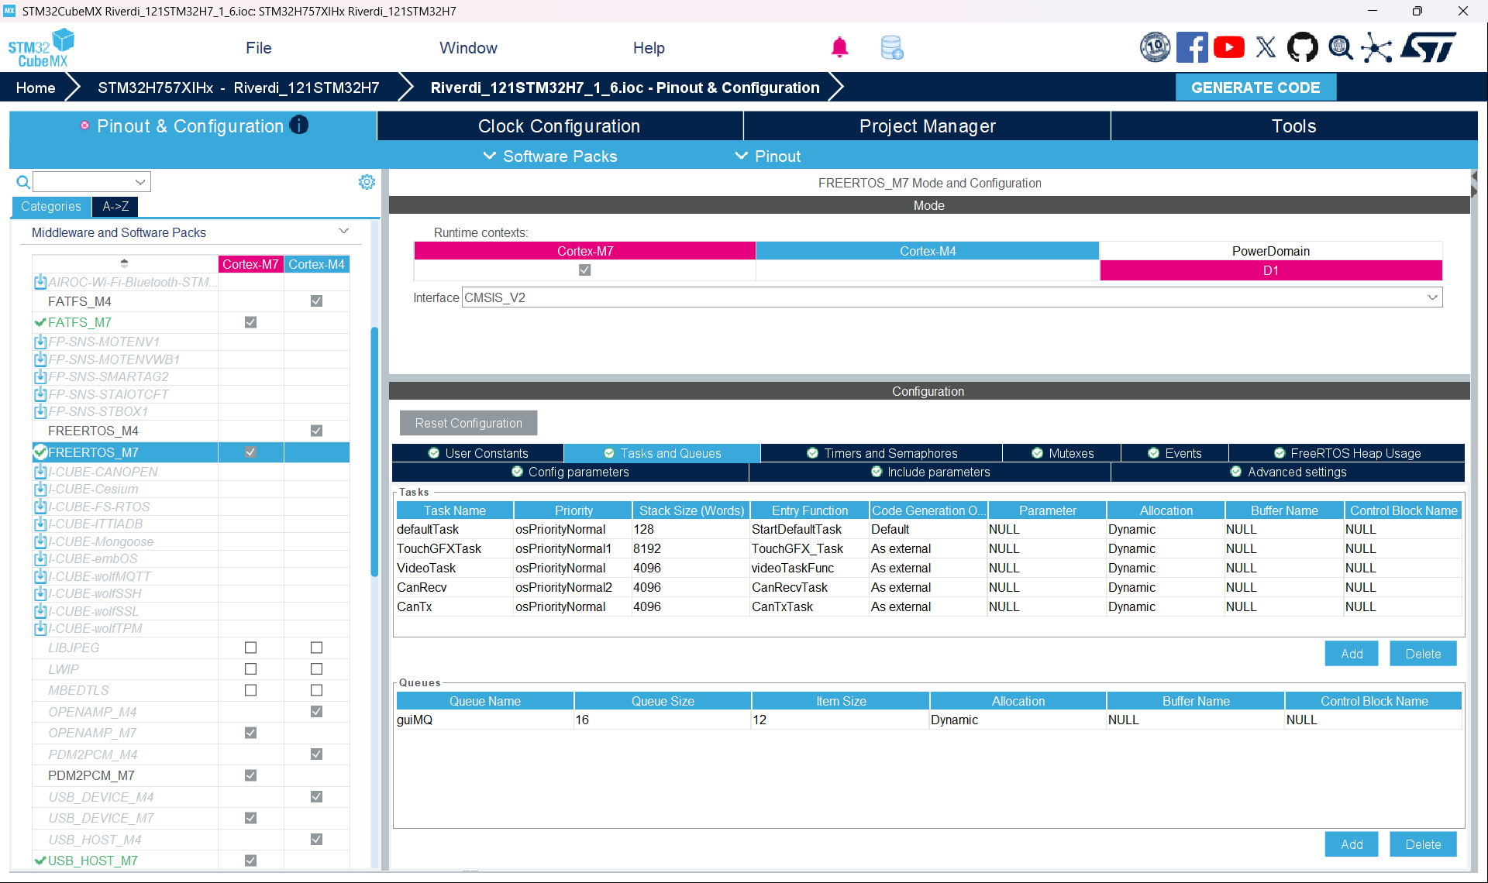
Every TouchGFX project also generates an IOC file. This IOC file is the RTOS configuration file that is loaded by the CubeMX software. For us, the most important parts are in the “Middleware and Software Packs”. The options here allow us to configure the FDCAN driver, add the relevant message queues, and configure the transmission and receive threads.
As can be seen from the diagram above, on the left-hand side, we selected the “FREERTOS_M7” to specify that we are configuring the STM32H7 processor. On the right-hand side, we see a lot of configuration options. However, only “Tasks and Queues” are relevant for us. We won’t get into the details about what a Task is or what a Queue is as they are core RTOS concepts but one must know what we are configuring.
A Task or a thread executes some backend functionality when triggered. This backend functionality can either be periodic or event-driven. This depends on the application, however, in safety critical systems, periodic (also called time-triggered) tasks are preferred for timing guarantees.
A Queue, as the name suggests, is a FIFO queue of the messages received over a communication interface. In FreeRTOS, we use the standard ring-buffer based queues. This is really nice because ring buffers are easy to implement and absolute no-brainer to read and write. Moreover, FreeRTOS also provides APIs to read and write the message queues.
An unconfigured TouchGFX project by default has three tasks: “defaultTask”, “TouchGFXTask”, and “VideoTask”. The stack sizes and other parameters of the tasks are preconfigured. For any new task, we configure these parameters manually. Although these parameters require a good understanding of the application, there are usually some well-defined values in HMI applications that we can use.
In the diagram above, we declared 2 tasks apart from the 3 already defined: CanRecv and CanTx. Depending on the requirement, we configured the priority of the tasks. FreeRTOS specifies priority levels rather than a fixed value. In this case, we use osPriorityNormal2 for receiver and osPriorityNormal for the transmission (osPriorityNormal2 < osPriorityNormal).
In general, in RTOS the priority of a task can be specified in many ways. The RMS (rate-monotonic systems) specifies that the priority of a task is inversely proportional to its period. This means a task whose period is faster (high frequency) has a higher priority than a task that has a slower period (low frequency). RMS is an optimal priority assignment and scheduling policy. We used RMS for priority assignment.
The name of the tasks in the above figure is the “handle” that the OS passes around as an identifier. However, we have to define the function that represents this task. In the “Entry Function” column, this is exactly what we specify. We are essentially saying that, “CanRecv task handle is an identifier, for the CanRecvTask function”. Always select “As External” for Code generation column. This ensures that no linking error creeps up during compilation.
In the box below the task definition, we specify a message queue. The column names are quite self-understandable.
Now, we look at some RTOS side code to see how these things are generated. Once, these are configured, in the TouchGFX Designer, click on generate. We get the configured OS in “CM7/Core/Src/freertos.c”. This code MUST be generated automatically because the rest of the OS depends on the configuration parameters generated in multiple places in the code-base.
With this done, we have a foundation upon which we can build. But don’t close the CubeMX just yet. Since we are working with the FDCAN, we need to configure some values for FDCAN also.
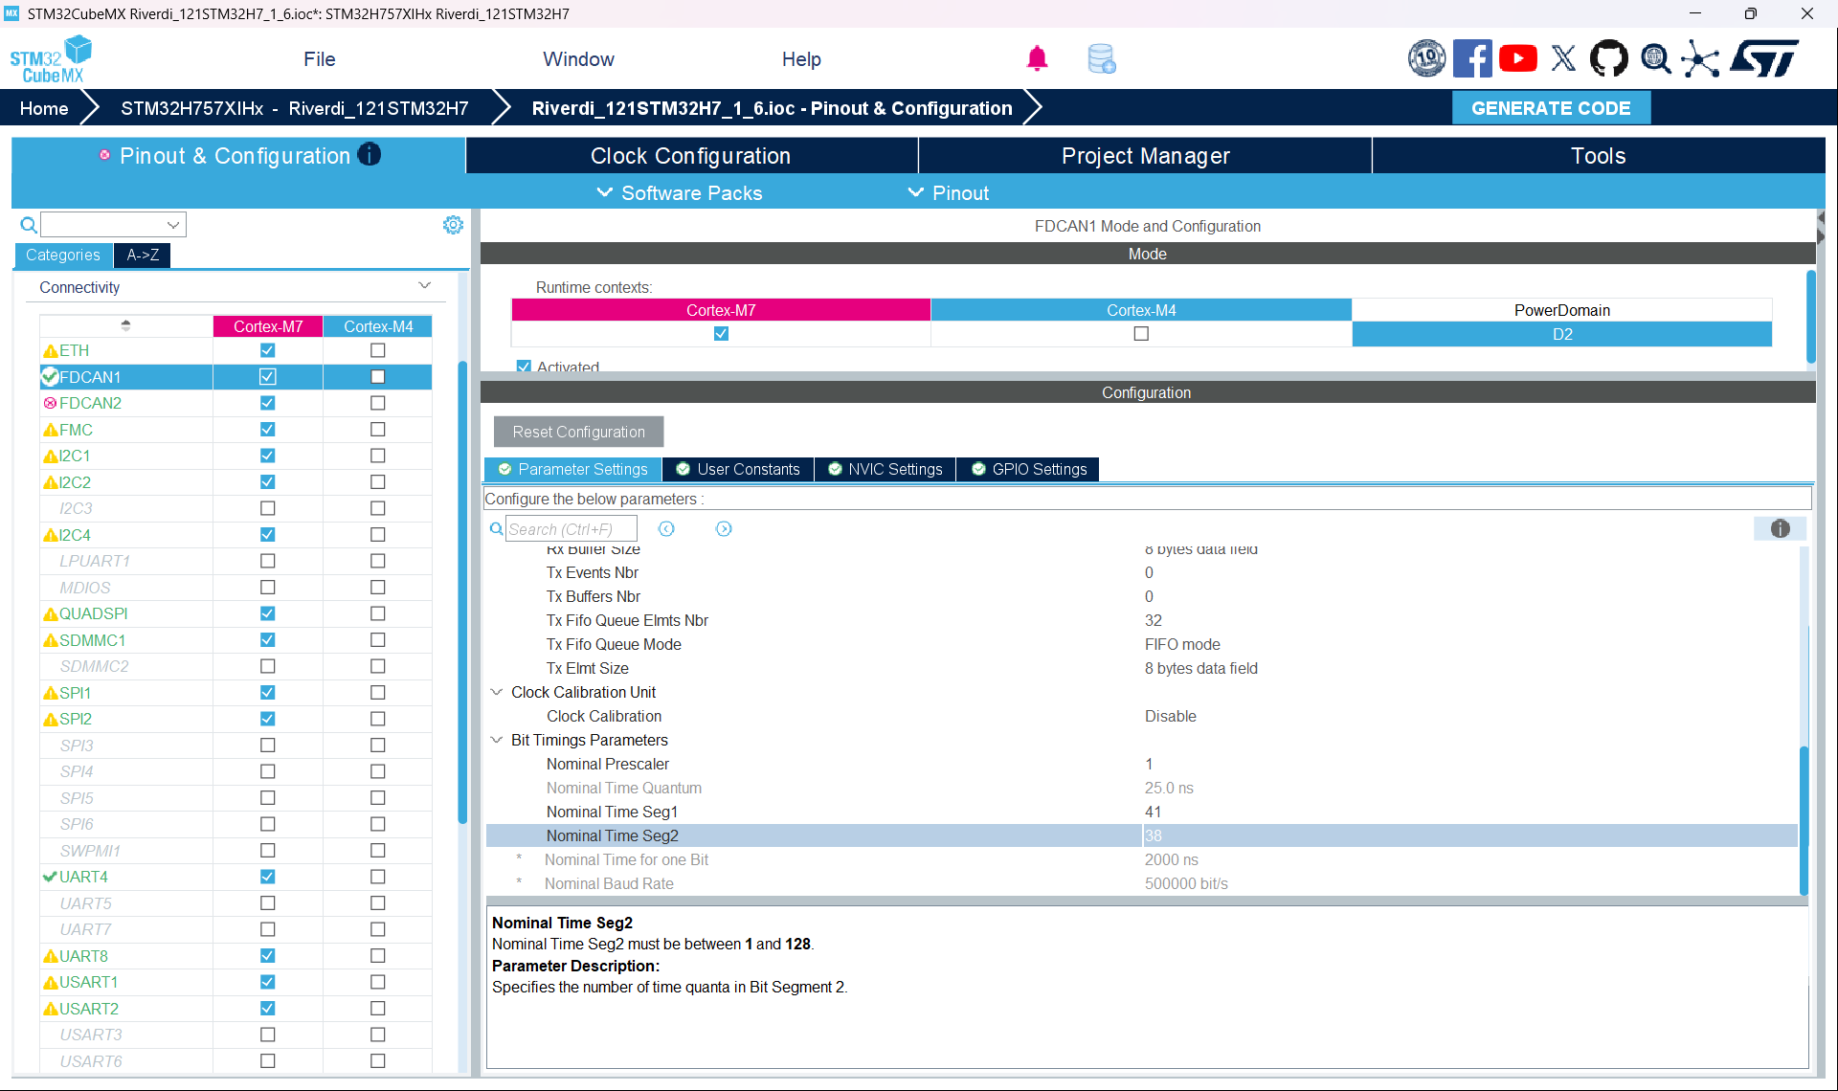
Navigate to the Connectivity drop-down in the left pane and select FDCAN1. On the Riverdi display there are two CAN channels. Since we are only using the FDCAN1 channel, we need to configure only this. The most important parameters here are the Time Seg1, Time Seg2 and the Tx FifoQueue Elmnts Nbr. The Tx FifoQueue Elmnts Nbr is set to 32 here and there no real reason as such. 32 ensures that there is enough space in the transmission message queue so that it does not drop messages. If 32 seems a lot (or less), change this number accordingly. But, as far as the TouchGFX document is concerned, the maximum can be 64 but that has never been tried.
The other two parameters are a bit tricky. These values specify the bitrate. We are communication over CAN at 500000 bits/s. These set the time segments for the CAN transceiver on the display to adhere to this bit rate. More information can be found at the Kvaser Bit Timing Calculator.
Now that the bit timing is also configured, click on Generate Code on the top right. This generates the RTOS configuration and also CAN bit-timing parameters. It is possible, but NOT ADVISABLE, to configure the RTOS manually. Manual configuration may lead to possible compilation, linking, and run-time errors that would be hard to debug.
CubeMX has a really nice documentation. Although most of the configuration is self-explanatory, it is advisable to skim through the documentation at least once.
Finally, the TouchGFX framework doesn’t use the FreeRTOS APIs and system calls directly. It uses the CMSIS wrapper layer. This wrapper layer is another layer of abstraction because STM32 supports more RTOSs other than FreeRTOS. This wrapper layer essentially abstracts away the underlying RTOS and gives the user a clean interface for development.

Setting up the FDCAN driver
Consider the following CAN signal (shared by the VCU team, for instance):

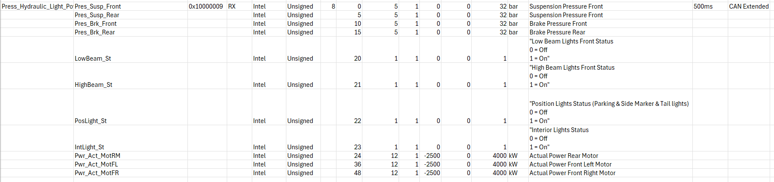

The signal consists of several values along with their offsets, scaling factors, and the maxima and minima. We will use this as a running example, and see the code that allows us to display these values from the CAN on the display.
We first convert this table into something that C/C++ understand.
#define CAN_ID_PRESS_HYDRAULIC_LIGHT_POWERTRAIN 0x10000009
typedef struct {
uint8_t Pres_Susp_Front;
uint8_t Pres_Susp_Rear;
uint8_t Pres_Brk_Front;
uint8_t Pres_Brk_Rear;
uint8_t LowBeam_St;
uint8_t HighBeam_St;
uint8_t PosLight_St;
uint8_t IntLight_St;
uint16_t Pwr_Act_MotRM;
uint16_t Pwr_Act_MotFL;
uint16_t Pwr_Act_MotFR;
} Press_Hydraulic_Light_PowerTrain_t;
Now, our main goal is to read the CAN ID 0x100000009, separate out these values from the signal, and display it on the HMI. All other signals can be found in the respective header files (betDbc.h for the Status display).
As one can see, the CAN ID is specific. In CAN, all the nodes connected to the bus can essentially receive all the data flowing in the bus. Therefore, one has to filter out only the required data. In our case, the good thing is that we are dealing with a specific range of the CAN IDs meant for the HMI. Therefore, we have to configure a filter in the FDCAN driver to filter out only the required range. To do this, we open the fdcan.c and add the filter to the MX_FDCAN1_Init function.
// --- FILTER CONFIGURATION ---
// We use one optimized mask to catch all IDs in range 0x10000000 - 0x100000FF
FDCAN_FilterTypeDef sFilterConfig = {0};

sFilterConfig.IdType = FDCAN_EXTENDED_ID;
sFilterConfig.FilterIndex = 0;
sFilterConfig.FilterType = FDCAN_FILTER_MASK;
sFilterConfig.FilterConfig = FDCAN_FILTER_TO_RXFIFO0;

// The Base ID: Matches the prefix of your signals
sFilterConfig.FilterID1 = 0x10000000;

// The Mask: Check top 24 bits (0x100000...), ignore last 8 bits
// This allows IDs 0x10000000 to 0x100000FF to pass.
sFilterConfig.FilterID2 = 0x1FFFFF00;
This ensures that we only receive the data in the range specified. Please refer to the “Known Bugs and Troubleshooting” section to know more about how to configure filters for IDs outside this range.

Receiver Task
void CanRecv(void *args)
{
FDCAN_RxHeaderTypeDef header;
uint8_t data[64];
CAN_Raw_Msg_t rawMsg;
const uint32_t taskPeriod = 10;
uint32_t tick = osKernelGetTickCount();

while(1)
{
tick += taskPeriod;
osDelayUntil(tick);

while (HAL_FDCAN_GetRxFifoFillLevel(&hfdcan1, FDCAN_RX_FIFO0) > 0)
{
if (HAL_FDCAN_GetRxMessage(&hfdcan1, FDCAN_RX_FIFO0, &header, rawMsg.data) != HAL_OK)
break;

rawMsg.id = header.Identifier;
osStatus_t status = osMessageQueuePut(guiMQHandle, &rawMsg, 0, 0);
if(status != osOK) {
SafeQueuePut(rawMsg.data);
}
}
if (HAL_FDCAN_GetRxFifoFillLevel(&hfdcan1, FDCAN_RX_FIFO0) > 0) {
osDelay(1); // give time back deterministically
}
}
}
The receiver task is a periodic task. The period is controlled by making the task sleep for 100ms before it wakes. After the task wakes, it enqueues the message in the receiver message queue (osMessageQueuePut(guiMQHandle, &rawMsg, 0, 0)) that we configured in the previous steps. The task then goes back to sleep and this keeps on repeating. This is the end of the road for the back end.
Now, if the CAN ID 0x10000009 is being transmitted over the CAN, the receiver will catch it and make it available to the system. We can keep on adding new signals in the form of a struct as shown above. Make sure to give meaningful names to the fields and the CAN ID.

Forwarding CAN data to the display
As previously stated, the Model is responsible for collecting data from the RTOS and make it available for the display. As shown above in the CanRecv task, we write the received data to the received message queue. In the Model, we read from this message queue and process the received message.
TouchGFX generates a lot of files. Most of them are not relevant for us as HMI developers. The important ones are:
- Model.hpp, modelListener.hpp and model.cpp: These are the class definitions and the implementation for the Model.
- Screen1Presenter hpp and cpp: This is the presenter interface that takes the data from the model and forwards the data to the view to display.
- Screen1View hpp and cpp: This updates the widgets with the data that we have read.

#ifndef MODEL_HPP
#define MODEL_HPP

#include "fdcan.h"

class ModelListener;

class Model
{
private:
// 1. Declare local structs to hold the thread-safe copies

Press_Hydraulic_Light_PowerTrain_t phlp;

public:
Model();

void bind(ModelListener* listener)
{
modelListener = listener;
}

void tick();

protected:
ModelListener* modelListener;

private:
bool parsePressHydLightPt(CAN_Raw_Msg_t, Press_Hydraulic_Light_PowerTrain_t *);
};

#endif // MODEL_HPP

Do not change the existing code in the hpp and the cpp files. Only add new code. For instance, in the Model.hpp we have added a function to parse the data that we read from the FDCAN message queue. The scope is set to private but one can change it to public. We have set private because we do not want the presenter to know how the data is parsed. The presenter only gets the parsed and processed data.
In the model.cpp, we implement the parser according to the information given in the CAN Matrix.
void Model::tick()
{
CAN_Raw_Msg_t rawMsg;

uint32_t processed = 10; // to avoid a storm of messages, process in frames

while(processed > 0 &&
osMessageQueueGet(guiMQHandle, &rawMsg, 0, 0) == osOK) {
switch(rawMsg.id) {
case CAN_ID_PRESS_HYDRAULIC_LIGHT_POWERTRAIN:
if(parsePressHydLightPt(rawMsg, &phlp))
modelListener->updatePressHydLightPt(phlp);
break;
}
processed--;
}
}
We implement the Model’s tick function that runs periodically and get the data from the receiver message queue (osMessageQueueGet(guiMQHandle, &rawMsg, 0, 0)). Based on the message ID, we switch to a specific parser, which in this case, is the parser for processing the CAN ID 0x10000009.
bool Model::parsePressHydLightPt(CAN_Raw_Msg_t rawMsg, Press_Hydraulic_Light_PowerTrain_t *_phlp) {
uint64_t rawVal;
bool changed = false;
float rawFloat;

rawVal = UnpackSignal(rawMsg.data, 0, 5);
if(_phlp->Pres_Susp_Front != rawVal) {
_phlp->Pres_Susp_Front = rawVal;
changed = true;
}

rawVal = UnpackSignal(rawMsg.data, 5, 5);
if(_phlp->Pres_Susp_Rear != rawVal) {
_phlp->Pres_Susp_Rear = rawVal;
changed = true;
}

rawVal = UnpackSignal(rawMsg.data, 10, 5);
if(_phlp->Pres_Brk_Front != rawVal) {
_phlp->Pres_Brk_Front = rawVal;
changed = true;
}

rawVal = UnpackSignal(rawMsg.data, 15, 5);
if(_phlp->Pres_Brk_Rear != rawVal) {
_phlp->Pres_Brk_Rear = rawVal;
changed = true;
}

rawVal = UnpackSignal(rawMsg.data, 20, 1);
if(_phlp->LowBeam_St != rawVal) {
_phlp->LowBeam_St = rawVal;
changed = true;
}

rawVal = UnpackSignal(rawMsg.data, 21, 1);
if(_phlp->HighBeam_St != rawVal) {
_phlp->HighBeam_St = rawVal;
changed = true;
}

rawVal = UnpackSignal(rawMsg.data, 22, 1);
if(_phlp->PosLight_St != rawVal) {
_phlp->PosLight_St = rawVal;
changed = true;
}

rawVal = UnpackSignal(rawMsg.data, 23, 1);
if(_phlp->IntLight_St != rawVal) {
_phlp->IntLight_St = rawVal;
changed = true;
}

rawVal = UnpackSignal(rawMsg.data, 24, 12);
rawVal = rawVal -2500;
if(_phlp->Pwr_Act_MotRM != rawVal) {
_phlp->Pwr_Act_MotRM = rawVal;
changed = true;
}

rawVal = UnpackSignal(rawMsg.data, 36, 12);
rawVal = rawVal -2500;
if(_phlp->Pwr_Act_MotFL != rawVal) {
_phlp->Pwr_Act_MotFL = rawVal;
changed = true;
}

rawVal = UnpackSignal(rawMsg.data, 48, 12);
rawVal = rawVal -2500;
if(_phlp->Pwr_Act_MotFR != rawVal) {
_phlp->Pwr_Act_MotFR = rawVal;
changed = true;
}

return changed;
}
The parser simply unpacks the signal according to the CAN Matrix and applies the scaling factor and the offset. Moreover, it also checks if the existing value is equal to the received value. This is robust design because the values of many of these signals do not change very often. Therefore, we update the display if and only if any of the value changes.
In the original implementation, this pattern is found in the entirety of the model.cpp. We add a parser in the model.hpp, then implement a switch case and the corresponding parser. Any new signal must adhere to this pattern.

From processed data to displayed values
If you look at the Model’s tick function above, there’s modelListener->updatePressHydLightPt(phlp);
This function invokes the Presenter. The Presenter reads the data and forwards it to the appropriate functions in the View.
To do this, we use the idea of virtual functions. We will not get into what a virtual function is, but we do need to define a virtual function called updatePressHydLightPt in the ModelListener.hpp and a normal function of the same name in the Screen1Presenter.hpp. We then implement this function in the Screen1Presenter.cpp as follows:
void Screen1Presenter::updatePressHydLightPt(Press_Hydraulic_Light_PowerTrain_t data) {
view.showPressHydLightPt(data);
}
We have kept the Presenter implementation extremely simple. It simply forwards the data to the view.
In the View, as stated before, we update the elements on the HMI with the values received over CAN. In this design, although the elements might be in different locations on the display, they are all updated from the same View function. For instance, the pressure, hydraulic, lighting, and powertrain data received from the CAN are displayed in different locations throughout the display. Since, they are all part of one CAN ID, we use one specific View function to update the elements.
When a new element is added in TouchGFX Designer, it generates an identifier for that element. Depending on the element, various TouchGFX APIs can be used. We will see how numerical values are updated. In this example, we will see how we set the front and rear suspension pressure reading that we get from the CAN.
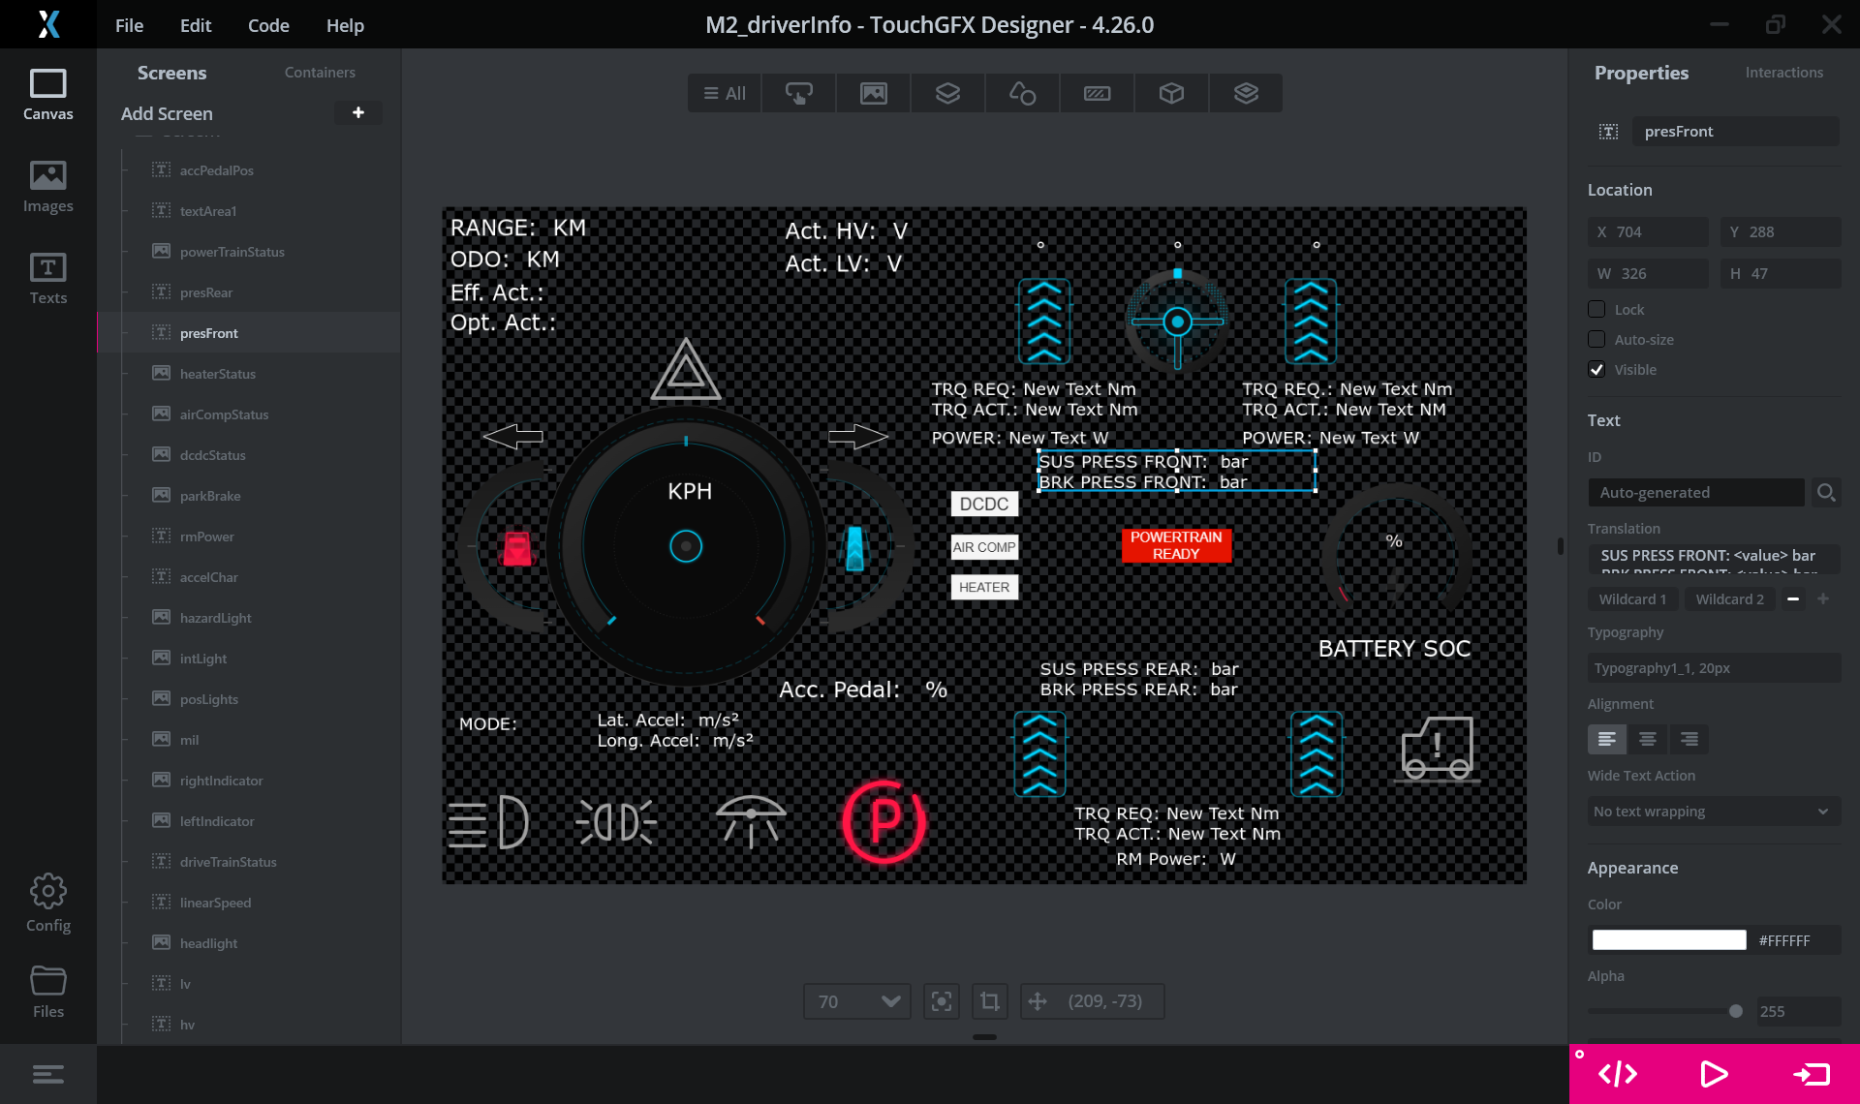
When a text box is added, we must first set the “name” of the text box. This is done from the top right corner (“presFront”). The next step is to tell TouchGFX that the value here is dynamic. In the right pane, under the Translation option, you can set what this text box must display, and also that some of that data is dynamic. Ensure that Wildcard1 and Wildcard2 is selected as, in this text box, we have two dynamic values. Also, ensure that you set the size of the dynamic data by clicking on Wildcard1 and Wildcard2 as shown below:
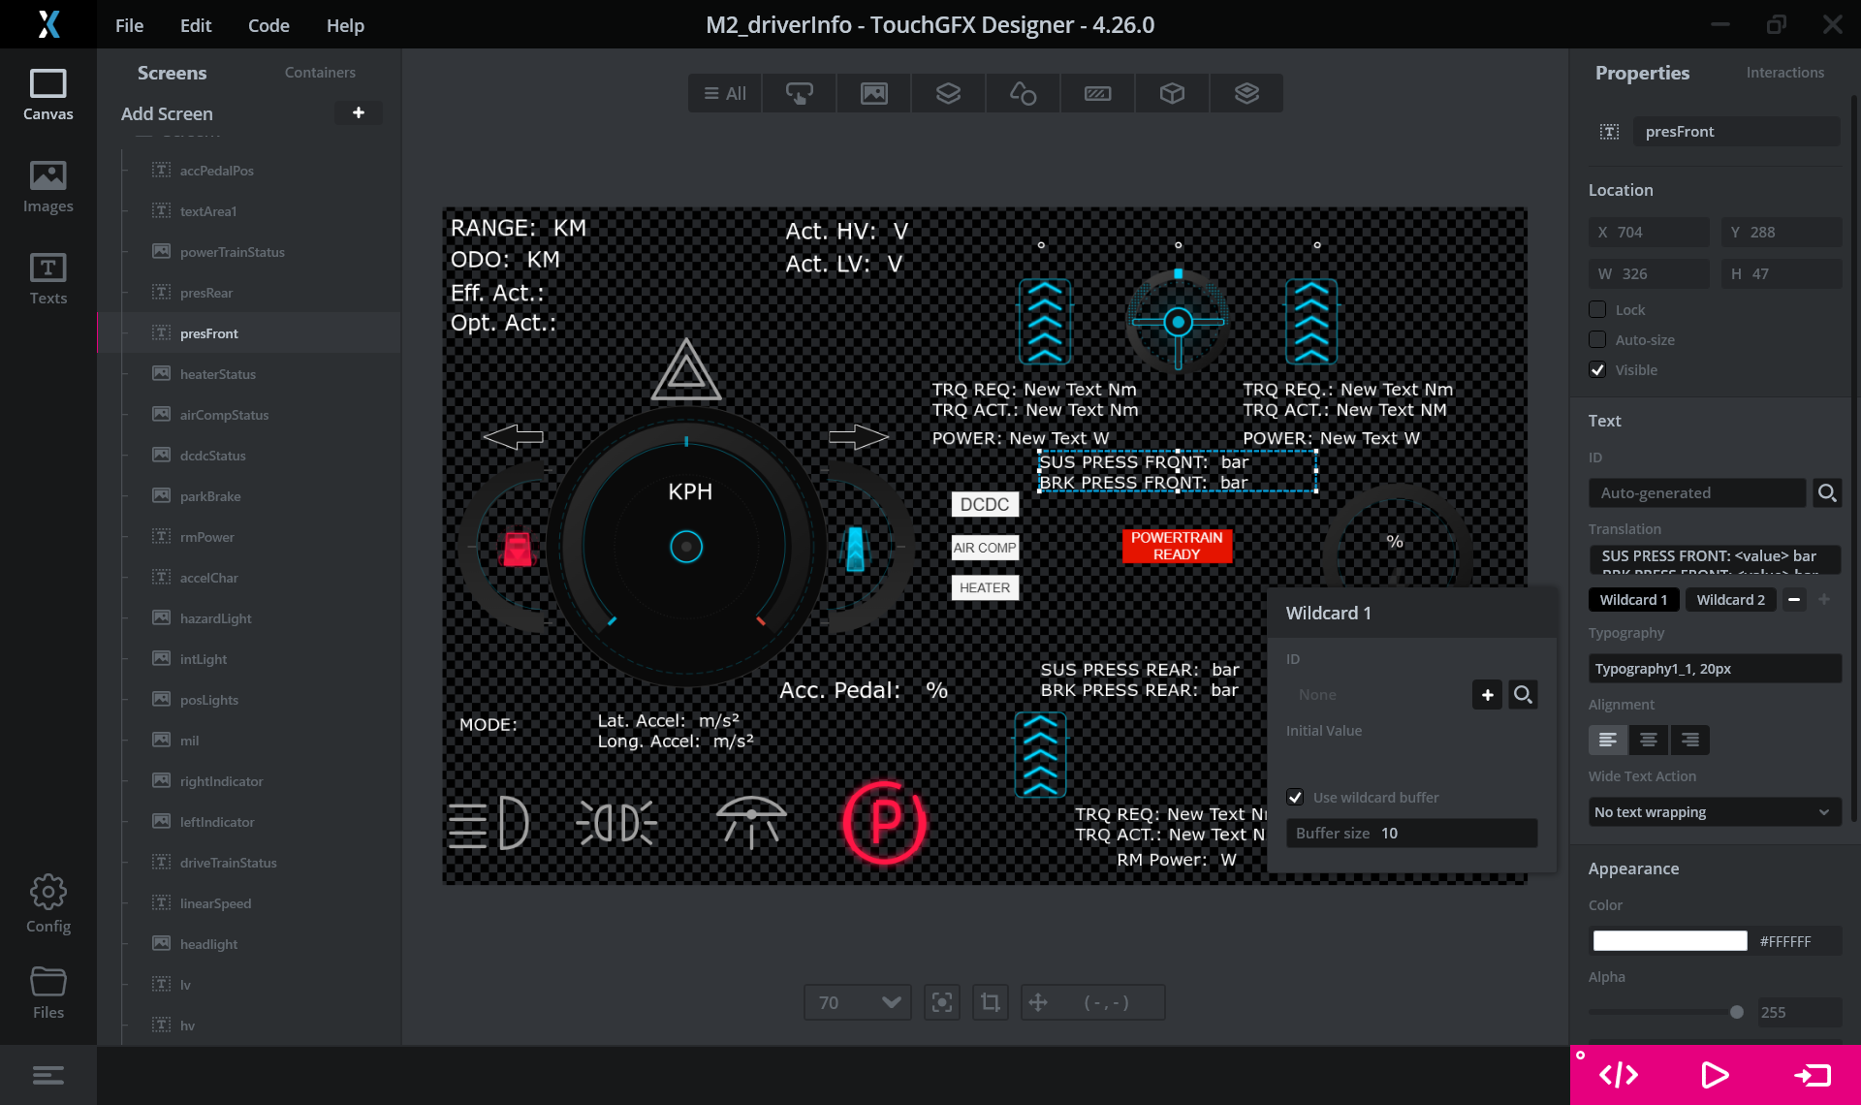

Once this is done, click on generate on the bottom right to generate the C++ representation of the GUI. This generates a “Screen1ViewBase.hpp” in CM7/TouchGFX/generated/gui_generated/include/screen1_screen. You can see your text box generated as:
static const uint16_t PRESFRONTBUFFER1_SIZE = 10;
touchgfx::Unicode::UnicodeChar presFrontBuffer1[PRESFRONTBUFFER1_SIZE];
static const uint16_t PRESFRONTBUFFER2_SIZE = 10;
touchgfx::Unicode::UnicodeChar presFrontBuffer2[PRESFRONTBUFFER2_SIZE];
We can write data to each of these buffers. The final step is to implement a function in the View that writes the data to these buffers.
In the Screen1View.hpp, we define a function prototype: void showPressHydLightPt(Press_Hydraulic_Light_PowerTrain_t);
Note that this function prototype has the same name as the one called from the Presenter in the previous step. We have defined this function with a public scope. Finally, we implement this function in the Screen1View.cpp
void Screen1View::showPressHydLightPt(Press_Hydraulic_Light_PowerTrain_t phlp) {
Unicode::snprintf(susFBuffer, SUSF_SIZE, "%d", phlp.Pres_Susp_Front);
susF.invalidate();

Unicode::snprintf(susRBuffer, SUSR_SIZE, "%d", phlp.Pres_Susp_Rear);
susR.invalidate();

Unicode::snprintf(brkPresFBuffer, BRKPRESF_SIZE, "%d", phlp.Pres_Brk_Front);
brkPresF.invalidate();

Unicode::snprintf(brkPresRBuffer, BRKPRESR_SIZE, "%d", phlp.Pres_Brk_Rear);
brkPresR.invalidate();
}
If you look closely, there is a pattern. We use the Unicode::snprintf function to write the CAN data to the buffer we configured using TouchGFX and then we call the invalidate function. The invalidate function MUST be there otherwise the display won’t update.
Now we have the complete flow:
- RTOS backend task receives data from CAN and pushes the data into the receiver message queue.
- Model reads the receiver message queue, processes the data, and forwards it to the Presenter.
- The Presenter forwards the processed data to relevant View functions.
- The View updates the specific elements.
The entire implementation has a very specific pattern that is apparent immediately. One only has to follow the existing code and the 4-step flow described above to update the existing and add new signals. The architecture also follows a similar process:
- Define the CAN ID and the corresponding struct in betDbc.h header file.
- Define a new parser in the model.hpp and a new virtual function that the Presenter will use to forward data to the View in the modelListener.hpp.
- Implement the parser defined in model.hpp in model.cpp
- Add a new switch case in the Model’s tick function that calls the parser, and conditionally calls the virtual function to forward the processed data to the Presenter.
- Implement the relevant functions in the Screen1View hpp and cpp and call the View function from the Presenter to display the processed data.

Known Bugs and Troubleshooting
Since there is a lot of traffic on the CAN network, it is possible that some data frames are dropped. An obvious solution is to increase the size of the receiver message queue but it may not be feasible always as there is a hard limit on the size of the queue.
In such a case, the solution is external. The CAN bus load must be controlled and lowered. However, one can try to increase (or decrease) the periodicity of the CanRecv task so that it reads the CAN network more (or less) frequently.
In this implementation, our CAN IDs are in a specific range and we have accordingly filtered the data. However, if a new CAN ID is added that is outside this range, a new range “mask” must be used. This is not as difficult as it seems.
Let’s say we want to read the CAN ID 0xCCFF3231. The best way is to add another filter as shown below:
// --- NEW FILTER FOR SPECIFIC ID ---
FDCAN_FilterTypeDef sFilterConfig2 = {0};

sFilterConfig2.IdType = FDCAN_EXTENDED_ID;
sFilterConfig2.FilterIndex = 1; // Use Index 1 (don't overwrite Index 0)
sFilterConfig2.FilterType = FDCAN_FILTER_RANGE; // Use RANGE for an exact match
sFilterConfig2.FilterConfig = FDCAN_FILTER_TO_RXFIFO0;
// Setting both ID1 and ID2 to the same value creates an exact match
sFilterConfig2.FilterID1 = 0xCCFF3213;
sFilterConfig2.FilterID2 = 0xCCFF3213;
HAL_FDCAN_ConfigFilter(&hfdcan1, &sFilterConfig2);
We can use the same idea from before if we want to filter a range instead of a specific ID.
The good thing is that all signals are Intel (Little Endian) byte ordered. However, in the future there might be signals that are big-endian byte ordered. The FDCAN driver already features a big-endian signal unpacker and a packer that can be used in these cases. The arguments are all absolutely the same and the Model-side code doesn’t change. Only ensure that the correct packer/unpacker is called.
Another known issue is that the displayed data is not formatted correctly. For instance, the data is expected with a precision of 2 decimal places but only one (or none) are shown. The problem comes from using the wrong display function.
As we saw above, we used the Unicode::snprintf function to display the values. This function is used for whole numbers and single characters (for instance, ‘P’ or ‘R’). To display a floating-point value, there is another function. In fact, TouchGFX has a whole suite of APIs that is way too long for this document. But the API documentation can be found here.
The code must be compiled using TouchGFX ONLY! The problem is that TouchGFX always compiles the code from scratch so it takes a long time.
To flash the code to the STM32H7 display use the STLinkV3 debugger. TouchGFX supports compiling AND flashing if the display is powered on and connected via the STLinkV3. Since the compiling takes a long time, it is strongly advised to add a complete signal, all the way from defining the struct definition, to updating the view elements before you compile.
Finally, to understand some more features, TouchGFX provides a lot of examples that you can run on the TouchGFX Simulator. However, note that the RTOS backend doesn’t work on the simulation. But the simulation is quite useful if you want to learn a new widget, for instance, TextureMapper for rotating and scaling images.
It should also be noted that the widgets provided by TouchGFX seem very complex from the outside. Inside, the way to manipulate the widgets is the same. However, care must be taken that relevant functions are used to update the widgets.

